
Sanctioned through Pacific Association USATF
May 10, 2014
9:00 AM – Running Events
8:30 AM – Field Events

Skyline High School
12250 Skyline Boulevard
Oakland, CA 94619

Age Division | Year of Birth | Group
6 – under | 2008+ | Group 0
7 – 8 | 2006 – 2007 | Group 1
9 – 10 | 2004 – 2005 | Group 2
11 – 12 | 2002 – 2003 | Group 3
13 – 14 | 2000 – 2001 | Group 4
15 – 18 | 1996 – 1999 | Group 5/6

- LIMITATIONS: Group 0 through Group 3 are limited to three events. Group 4 and 5/6 are limited to four events.

- ENTRY FEE: $7 per athlete

- NOTE: If participating in a mixed medley relay, the athletes can run up but CANNOT run down, i.e. in the mixed sprint medley Group 1 athletes can run the 100m, 200m, or 400m. However a Group 3 or Group 4 athlete cannot run the 100m and Group 4 athletes cannot run the 200m. Also must be same gender. Group 0 athletes may run in place of Group 1 athletes for relays only.

- REGISTRATION & ENTRY FEES: Registration and meet entries should be completed at the Coach-O website (CLICK HERE TO REGISTER) no later than Wednesday, May 7, 2014. There will be NO day of the meet entries or changes! All entries made by the deadline should be printed for verification purposes. Entry fee is $7 per athlete. Fees must be paid online after you complete your entries.

- COACHES MEETING: There will be a coaches meeting on the infield at 8:00 AM. A representative from each team should be present. Scratches should be made during this time.

- AWARDS: Ribbons will be awarded to the 1st – 6th heat places. Medals will be awarded for 1st – 3rd overall places for the 1500m and Mini Jav only.

- CONCESSIONS: A hearty snack bar featuring Flavors Cinnamon Rolls® will be available, so bring an appetite!

ATTENTION COACHES AND PARENTS!!!
There will be 2 SEPARATE raffles held. One for an autographed photo of Stephen Curry and another for an official NBA regulation basketball autographed by the entire Golden State Warriors team!
A representative must be present to win. Drawings will be held at 3:00 PM and 4:00 PM respectively. Pre-sale raffle tickets are available NOW so CLICK HERE TO PURCHASE TICKETS.
$1 for 1 ticket
$5 for 6 tickets
$5 for 8 tickets (PRE-SALE ONLY)
REMEMBER: On day of meet, bring online receipt to pick up & confirm pre-sale tickets.

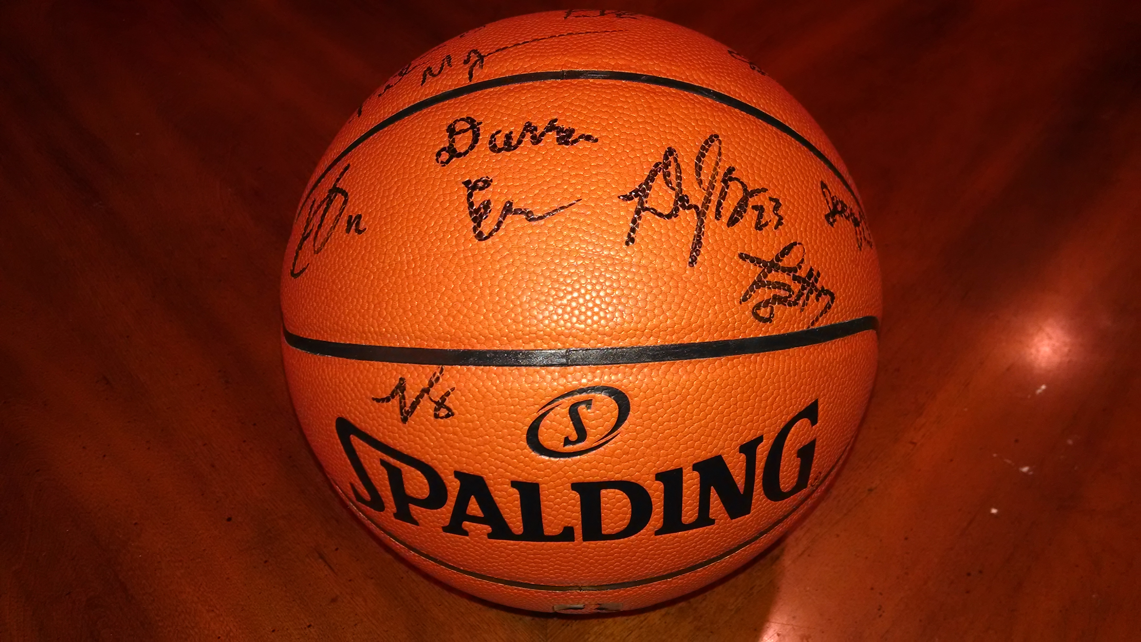
Autographed photo of Stephen Curry, signed with Certificate of Authenticity.
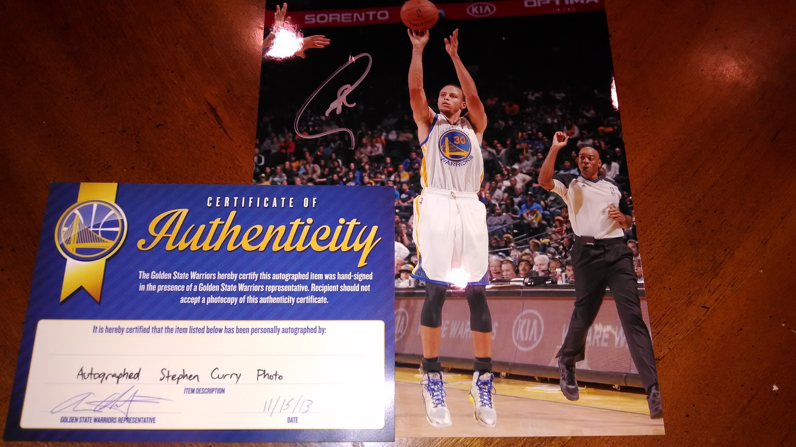
NBA regulation basketball signed by the entire Golden State Warriors team with Certificate of Authenticity. Imagine this on your mantle.
Hampton-Phillips Classic Track Club
May 10, 2014

SCHEDULE OF EVENTS
TRACK EVENTS – 9:00 AM start time

1500 meter race walk | Group 2, Group 3
3000 meter race walk | Group 4, Group 5/6
4x100 meter relay | Group 0, Group 1, Group 2, Group 3, Group 4, Group 5/6
4x800 meter relay | Group 1, Group 2, Group 3, Group 4, Group 5/6
1500 meter run | Group 1, Group 2, Group 3, Group 4, Group 5/6
Mixed Sprint Medley relay (100, 100, 200, 400) | Group 1(100), Group 2(100), Group 3(200), Group 4(400)
50 meter dash | Ages 5 and under only
400 meter dash | Group 0, Group 1, Group 2, Group 3, Group 4, Group 5/6
100 meter dash | Group 0, Group 1, Group 2, Group 3, Group 4, Group 5/6
Sprint Medley relay (100, 100, 200, 400) | Group 1, Group 2, Group 3, Group 4, Group 5/6
800 meter run | Group 1, Group 2, Group 3, Group 4, Group 5/6
200 meter dash | Group 0, Group 1, Group 2, Group 3, Group 4, Group 5/6
4x100 meter parent/coach relay
4x200 meter relay | Group 0, Group 1, Group 2, Group 3, Group 4, Group 5/6

FIELD EVENTS – 8:30 AM start time

Long Jump | Group 0 | 8:30 |  | Shot Put | Group 1 | 8:30
Long Jump | Group 5/6 |  |  | Shot Put | Group 2
Long Jump | Group 4 |  |  | Shot Put | Group 3
Long Jump | Group 3 |  |  | Shot Put | Group 4
Long Jump | Group 2 |  |  | Shot Put | Group 5/6
Long Jump | Group 1
 |  |  |  | Mini Jav | Group 3 | 8:30
 |  |  |  | Mini Jav | Group 2
 |  |  |  | Mini Jav | Group 1
 |  |  |  | Long Tom | Group 4 | Following
 |  |  |  | Long Tom | Group 5/6 | Mini Jav

